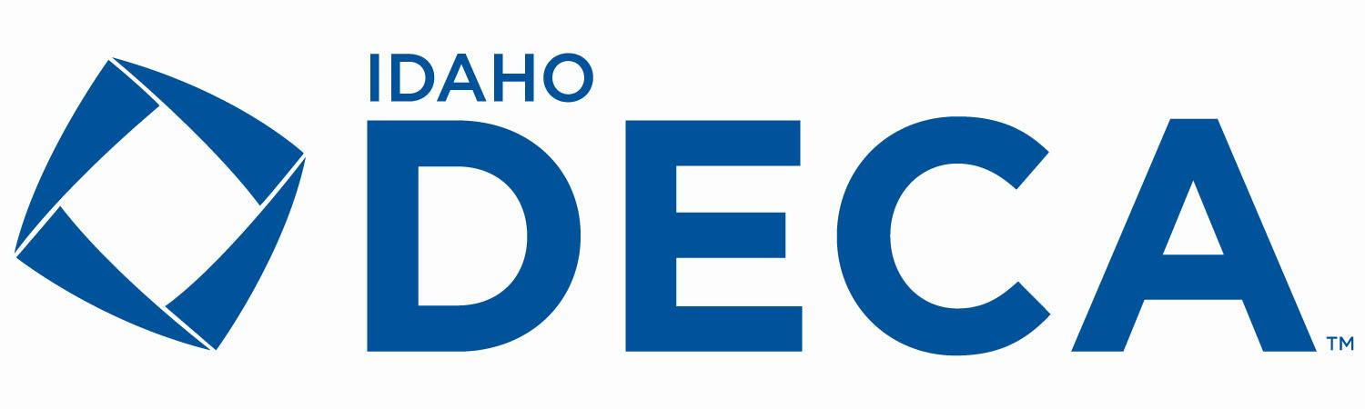
ADVISOR OF THE YEAR AWARD
All nominees will be recognized on stage at SCDC, and one nominee will be chosen from the entries to receive the 2026 Idaho DECA Advisor of the Year award.
An advisor may consecutively hold the “Idaho DECA Advisor of the Year” title.
The Advisor of the Year award serves to recognize advisors that have risen above the rest. Members will write a 2-page paper (maximum) that touches on each of the following subjects to create a compelling argument as to why their advisor deserves to be the Advisor of the Year.

- Chapter management
- Conference/ event participation
- Drive to help their members succeed

DESCRIPTION
The Advisor of the Year Award consists of a 1 paragraph - 2 page written report that describes why your advisor should be chosen as Idaho DECA’s 2026 Advisor of the Year. Examples of excellence in each of the three areas identified will be submitted to the judges.

CHAPTER INSTRUCTIONS
These guidelines serve as your instructions for your written report.

GUIDING PRINCIPLES
Our guiding principles explain how we fulfill our mission by addressing what we do and the outcomes we expect. DECA enhances the preparation for college and careers by providing co-curricular programs that integrate into classroom instruction, apply learning in the context of business, connect to business and the community and promote competition. Our student members leverage their DECA experience to become academically prepared, community-oriented, professionally responsible, experienced leaders. Keep our DECA guiding principles in mind when choosing what to include in your report.

GUIDELINES FOR THE WRITTEN REPORT

TITLE PAGE
The title page will not be numbered
Name of DECA Chapter/ High School
School address
Advisor’s name and email
Name and title of student writing the report for their chapter
(ex: John Johnson - Chapter President, Chapter Officer, Chapter Representative, etc.)

BODY OF THE WRITTEN ENTRY
The body of the written entry consists of a maximum of 2 pages that touch on the three categories described above.

FORMAT REQUIREMENTS
- Title page requirements listed above
- Number pages following the title page
- One paragraph minimum, two pages maximum
- Use your best judgement in spacing, font type, and font size
- Decorative artwork, pictures, and illustrations are welcome to be used throughout the entry as long as they are relevant
- Submission requirements described below

DUE DATE: January 9, 2026
Submit your written report via email to Gina Lyman at gina.lyman@cte.idaho.gov with the subject line “Advisor of the Year candidate ___name of your high school_____”

DO NOT type your entry directly in the email, submit it as an attachment as a Word document, Google doc, or .pdf

Idaho DECA Advisor of the Year - Written Entry Checklist and Evaluation Form
 | No  Value | Little  Value | Adequately Done | Well  Done | Outstanding | Judges  Score
Chapter Management  Does the advisor adequately and efficiently manage their chapter? | 0  1  2 | 3  4 | 5  6 | 7  8 | 9  10
Conference/ Event Participation  Does the advisor attend/ take their chapter members to leadership events and conferences? | 0  1  2 | 3  4 | 5  6 | 7  8 | 9  10
Drive to Help Members Succeed  Does the advisor genuinely care for the organization of DECA and the well being/ success of their chapters’ members? | 0  1  2 | 3  4 | 5  6 | 7  8 | 9  10
Overall Impression of Report  Overall professionalism of the written report spelling, grammar, events, formatting, etc. | 0  1  2 | 3  4 | 5  6 | 7  8 | 9  10
 |  |  |  |  | Total Points | /40

